Software Requirements Specification
for
Parts Crib Database Project
Version 1.0 approved
Prepared by Ifeoluwa David Adese, Mohand Ferawana & Tosin Ajayi
Humber College Final Year Computer Engineering Capstone Project
February 8th, 2018
Table of Contents
Table of Contents ii
Revision History ii
1. Introduction 1
1.1 Purpose 1
1.2 Intended Audience and Reading Suggestions 1
1.3 Product Scope 1
1.4 References 1
2. Overall Description 1
2.1 Product Perspective 1
2.2 Product Functions 2
2.3 User Classes and Characteristics 3
2.4 Operating Environment 3
2.5 Design and Implementation Constraints 3
2.6 User Documentation 3
2.7 Assumptions and Dependencies 3
3. External Interface Requirements 4
3.1 User Interfaces 4
3.2 Hardware Interfaces 4
3.3 Software Interfaces 4
3.4 Communications Interfaces 4
4. System Features 5
4.1 User Authentication 4
4.2 Student Rentals and Returns Feature 5
4.3 Update user profile and item information 5
5. Other Nonfunctional Requirements 5
5.1 Performance Requirements 5
5.2 Safety Requirements 6
5.3 Security Requirements 6
5.4 Software Quality Attributes 6
5.5 Business Rules 7
6. Other Requirements 7
Appendix A: Glossary 7
Appendix B: To Be Determined List 7

Revision History
Name | Date | Reason for Changes | Version

Introduction

Purpose
The Parts Crib Database is a project designed for Humber College’s School of Applied Technology Parts Crib Department. The project’s main objective is to help improve accountability for tools and equipment at the crib. Other benefits of the project include; faster lending procedure at the part crib during peak lab hours, monitored record of students with pending returns as well as easy update of inventory record for all tools and equipment.

Intended Audience and Reading Suggestions
The intended audience for this document include users, testers, documentation writers, developers and project managers. This SRS also contains, in this order, a detailed overall project description, interface requirements, system features, functional and non-functional requirements etc. Reading this document in the order listed in its table of contents is advisable to all intended audience for easy understanding.

Product Scope
There are two main software specified in this document; a mobile application and a web application. The web application is designed for both administrative users and registered student users but will be mainly used by administrators i.e. the parts crib employees, while the mobile application is also designed for both administrative users & registered student users but will be mainly used by students. The goal was to provide students with an easy on-the-go access to their accounts, in order to keep them updated on available tools and equipment and also make personal account updates from anywhere, at any time. No business strategies involved.

References
- Principles of Mobile App Design: Engage Users and Drive Conversions
- Fundamentals of Relational Database Design
- Web Application User Interface Design Basics
- How we started developing a car rental mobile app & ended up building a car rental website
- 11 Web Application Security Best Practices

Overall Description

Product Perspective
There are four major required parts that materialize this project. These include an online relational database hosted on a remote server for storing user and equipment data, a web application, an android mobile application as well as the hardware which could be any of the three proposed ID-reading effectors by the group members i.e. a USB barcode scanner, a magnetic strip card reader or a PC2 barcode scanner. This document will place focus on just the requirements for the web and mobile applications as well as some necessary information on the database.
In the overall project design, the mobile and web applications are both set up to interact with the same remote server. However, the mobile application will function independently to exchange information with the database, while the web application will sometimes, although not necessarily, require the hardware for scanning student IDs, which is somewhat faster. The illustration below shows the general system design.

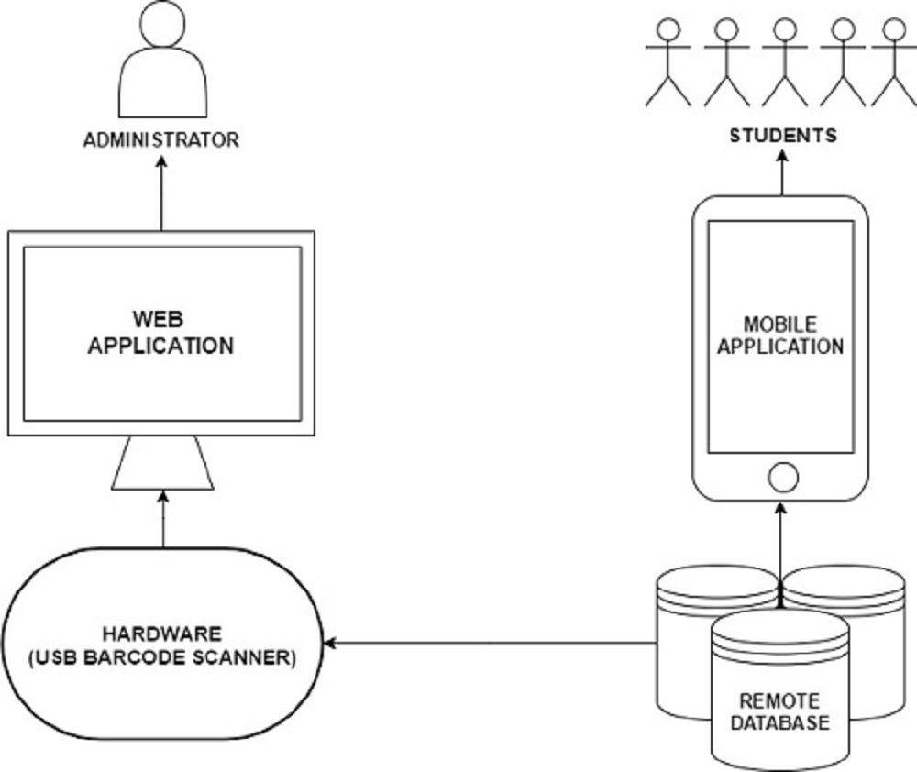

Product Functions
The functions made available to a user is dependent on the user type. i.e. student or administrative user. However, both students and admin have access to basic user functions like user login, profile and password update as well as view available equipment record. Functions designed specifically for administrative users include:

- Registration and deletion of users.
- View student profile, view student cart and view student possessions.
- Approve and edit student cart and update student possessions.
- View list of students holding a specific item.
- View and update equipment information.

On the other hand, functions designed specifically for student users include:

- User login functionality.
- View available tools and equipment.
- View and edit personal cart. i.e. unapproved items.
- View personal possessions. i.e. approved items.

User Classes and Characteristics
This product will not only be beneficial to the parts crib and students of Humber College’s applied technology programs. It can also be implemented in libraries, bookstores or any other institution or organization offering free rental services to clients, provided there is an existing relational database. Therefore, the only expected changes to be made before implementation will be the kind of information stored in the database. In addition, irrespective of the user type i.e. admin or client, no level of expertise or training will be required to operate the product.

Operating Environment
The mobile application will be compatible with only android devices (tablets and phones) with versions starting from 1.0 up to the latest version 8.1. The web application will also be compatible with all desktops and personal computers using any browser on any kind of operating system. The hardware will also be compatible with any computer, provided there is port that suits the device’s connection cable. For example, the USB barcode scanner will have to be plugged into a USB port on the computer running the web application to function. A stable internet connection will also be required for both mobile and web application to connect and interact with the online database.

Design and Implementation Constraints
In terms of design and implementation constraints, the only major limitations developers might encounter will be the implementation of a non-relational database into the system design. There are specific PHP/SQL scripts that carry out the main exchange of data in a specific format between the mobile/web application and the database. So, implementing a non-relational/no-SQL database might cause certain complications and force developers to undergo an intensive system redesign. Other less threating limitations include the fact that the mobile application is only available for android users and only supports two languages i.e. English and French.

User Documentation
A descriptive video tutorial, a wire-framed documentation and a well detailed FAQ, for both web and mobile applications will be provided to answer possible questions or any predicted issues that may arise from users. All three user documentations will be provided mainly in the help section of the web application and also made accessible from the mobile application by simply redirecting users upon selection.

Assumptions and Dependencies
Both mobile and web applications are highly dependent on a bunch server-side scripts written in PHP and SQL. These scripts are hosted on an online remote server purchased from HostGator; a company that provides servers for online web hosting as well as database management and web design tools like MySQL, PhpMyAdmin, File Manager etc. These scripts are mainly responsible for the exchange of data between the mobile/web application and the provided database. Without these scripts, absolutely nothing can function. In a scenario where by the implemented database is to be replaced, then these scripts will also have to be altered in some areas to function properly.

External Interface Requirements

User Interfaces
The user interface design will vary on both mobile and web platforms. On the mobile application, the administrative home screen will be a sectional menu holding the most important admin functions, while the student home screen is a direct access to list of available tools and equipment as well as buttons that redirect the user to view cart and view personal possession. A navigation drawer will also be present at the top right-hand corner of every screen on the mobile application for both administrative and student users. This navigation drawer will contain other frequently needed feature options common between both user types for easy access. These options include; return to home, edit profile, change password, logout, view student cart, view student possession etc.

On the web application, both user types will be operating mainly on simple web page with a left-sided navigation drawer covering about one-fourth of the screen. Again, the idea with the navigation drawer is simply to provide the user with easy access to a list of frequently needed feature options. The remaining three fourths of the screen will be the main screen for operational activities by the user. A user interface specification describing style design and layouts for each functionality screen can be provided upon request.

Hardware Interfaces
The hardware only requires one interface, which is a text field; any text field. The text field has to be on an application running on a device with HID keyboard recognition. The major function of the hardware when an ID is scanned is to decode raw the data, perform a parity-check and then print out the decoded information. This process happens to work even better on a web application. When the hardware i.e. the barcode scanner, was tested on Google’s search engine, the data was not only scanned but the search function was also automatically triggered. Same with our web application, when a valid ID is scanned, the enter function is also automatically triggered without the user having to click a button, so the server feedback is received almost immediately. Nothing else asides a text field on a device with HID keyboard recognition, is required to utilize the hardware.

Software Interfaces
The whole system is highly dependent on transmission of data between the mobile/web application and the remote server. On the mobile side, the data sent to the server is usually encoded in raw data, but after the message is interpreted, feedback is received in JSON format. The data sharing method is usually carried out on a separate thread from the main thread in order to keep the data flow asynchronous. On the web application side, the user interface and data transmission scripting are all done on the server.

Communications Interfaces
The only communication functions required by this product on the mobile application side is the HTTP network protocol. The httpurlconnection API available on android platforms enabled remote connection to the server from any mobile device. On the web application side, no protocols were required because connecting to the database directly was much easier using server-hosted PHP scripts. However, electronic forms were required on the web application in communicating with users on the kind of information needed.

System Features
The following listed system features are the main functionalities required for the software systems i.e. both mobile and web applications. These features include:

User Authentication
4.1.1 Description and Priority
The user authentication procedure is a process which involves the validation of user credentials during the login or registration process. It has the highest priority in both software systems i.e. mobile and web. It is usually executed on specific server-side scripts before returning a feedback to the application whether the credentials entered by the user are valid or not. This determines if the user will be granted access to a certain page or feature.
4.1.2 Stimulus/Response Sequences
During the login procedure, there is a server script mainly responsible for verifying that the username or email entered matches the password of the user entered. During the registration process, the server also verifies that the user or item name, email or item serial number is not already existing in the database. This helped avoid duplicate values in columns where data is expected to be a primary or unique key.
4.1.3 Functional Requirements
TBD (To be discussed).

Student Rental and Return Feature
4.1.1 Description and Priority
The student rental procedure is the process which involves selection of tools added to a cart by a student user and approved by an administrative user. On the other hand, the returns procedure is the process whereby a list of student possessions i.e. unreturned approved items, are edited based on the quantity of specific equipment returned.

4.1.2 Stimulus/Response Sequences
Basically, students can make selections on items which will be added to a cart. this cart can be later edited by students. On the other hand, administrative users can gain access to view any student’s cart, if the correct student ID is provided. Admin user can also edit this cart on the behalf of the student. Only an administrative user has the ability to approve items in a student cart, which then converts the cart items to student possession items. Also, only admin users can edit student possessions.

4.1.3 Functional Requirements
TBD (To be discussed).

Updating User Profile and Item Information
4.1.1 Description and Priority
This is simply the remote manipulation or replacement of already existing user or item information from the web or mobile application.
4.1.2 Stimulus/Response Sequences
This procedure is quite similar to the registration process. The only difference in the PHP/SQL scripting is the fact that the user data received by the server is not inserted into the appropriate table, instead an existing row is simply updated. However, specific validation procedures will be taken to ensure that valid and non-duplicate information is allowed into the database.
4.1.3 Functional Requirements
TBD (To be discussed).

Other Nonfunctional Requirements

Performance Requirements
The mobile application and the web application are not too dependent on any factor for its overall performance, except for network conditions. The system generally requires a stable internet access in order to connect to the server and transmit data back and forth. Other than that, no other factor is significantly responsible for its performance.

Safety Requirements
There are no safety requirements that apply to the software aspect of the overall product system. However, on the hardware side, the only precautional measure that should be taken when using the barcode scanners in order to prevent health risks is to avoid laser contact with the eyes as it may cause retinal damage in reaction to bright light. The barcode scanner emits some infrared lasers which can be dangerous to the eyes. Although these emissions are very low and not so significant to make an impact, it should still be taken into consideration as a safety hazard.

Security Requirements
As of now, no security issues have been identified, except for the fact that no security certificate has been issued by our web hosting company. The server still runs on an insecure HTTP protocol, which makes all other sub systems including the database highly vulnerable to malicious web users. This, however, will not be an issue for too long as it can be easily rectified.

Software Quality Attributes
The following software quality attributes are considered to be the main objectives for the overall system upon completion; adaptability, availability, inter-operability, maintainability, flexibility, robustness, portability, manageability, performance, reliability, scalability, security, supportability, testability, user experience and usability.

Business Rules
TBD (To be discussed).

Other Requirements
No other requirements involved.
Appendix A: Glossary
- API – Application Programming Interface
- HID – Human Interface Device
- HTTP – Hypertext transfer protocol
- ID - Identification
- FAQ – Frequently Asked Questions
- SQL – Structured Query Language used for relational database management

Appendix B: To Be Determined List
- User Authentication Functional Requirements.
- Student Rental and Return Feature Functional Requirements.
- Update User Profile and Item Information Functional Requirements.
- Business Rules for Non-functional Requirements.

